

CSE 3224

**INFORMATION SYSTEM DESIGN AND SOFTWARE ENGINEERING LAB**

pRIMARY PROPOSAL PRESENTATION

Submitted by

**Samin Shahriar Tokey** | 14-02-04-066

**Biozid Niloy** | 14-02-04-070

**Naimul Haque** | 14-02-04-080

**Sanaul miraj** | 14-01-04-131

Greener Earth

A website on Climate Change

**Introduction**

A website dedicated to educate and raise people's awareness for the climate change. A collection of news reports about the environment, global warming, climate change, green living and many more topics, from across the globe, with links to excellent resources explaining the science and evidence for climate change and views of climate scientists. Read the latest healthy debates on environmental concerns, climate change, green living, transport, conservation movements and campaigns.

**Why greener earth?**

Most people are ignorant and careless about climate change. Our goal is to reach out to everyone and to inform them about the effects and consequence of climate change.

**Project goals**

* A website dedicated to educate and raise people's awareness for the climate change.
* Various topics, from across the globe, with links to excellent resources explaining the science behind climate change.
* Giving people opportunity to create accounts.
* Making people create forums and threads to discuss with others.
* Make people read the latest healthy debates and blogs on environmental concerns, climate change, green living, transport, conservation movements and campaigns.

**Features & Uses**

* Various blogs from scientists’ expert in climate science.
* Useful links related to climate change.
* Create personal accounts.
* Opportunity to create discussion forum.
* Taking surveys about climate change.
* Give Ideas, views and ways to tackle this problem, see what others think about what could be the possible solution.
* Opportunity to donate for the betterment of mankind.
* Anyone can give ideas without creating an account.
* Everybody can view the discussion board and forums.
* Dedicated Admin Panel

**Feasibilities**

* **Technical Feasibility:**
* As we are using PHP as server side language, it will be:
* Reliable
* Available
* Compatible with any kind of upgrade.
* And using HTML & CSS to make the interface, gives us:
* Better & attractive design
* We are using MySQL as our primary database which gives us:
* Flexibility and ease of storing various information
* Ease of changing any information
* Robust and secure
* Moreover, we will be using JavaScript and JQuery to make the website more responsive and feature rich.
* **Economic Feasibility:**
* Cost of programmer, debugger, tester
* Cost of server, storage, internet connection
* Cost of full system study
* Salary of operators
* Handling donations properly
* **Operational Feasibility:**
* Create social awareness
* Tackle climate change with the most scientific ways
* Free of cost service with voluntary donation opportunities
* Provide 24-hour access for the users
* Provide a secure and friendly interface for the users
* Fast and reliable server

**Project Scheduling**

|  |  |  |  |
| --- | --- | --- | --- |
| **Activity** | **Description** | **Predecessor** | **Time (Days)** |
| **A** | **Communication** | **None** | **14** |
| **B** | **Project Initiation** | **None** | **7** |
| **C** | **Requirement Gathering** | **B** | **7** |
| **D** | **Planning** | **C** | **20** |
| **E** | **Scheduling** | **C** | **5** |
| **F** | **Modeling** | **D** | **14** |
| **G** | **Analysis** | **D** | **12** |
| **H** | **Design** | **G** | **7** |
| **I** | **Construction** | **H** | **21** |
| **J** | **Coding** | **H** | **14** |
| **K** | **Test** | **J** | **5** |
| **L** | **Deployment** | **K** | **14** |
| **M** | **Feedback** | **K** | **10** |
| **N** | **Presentation** | **L** | **1** |

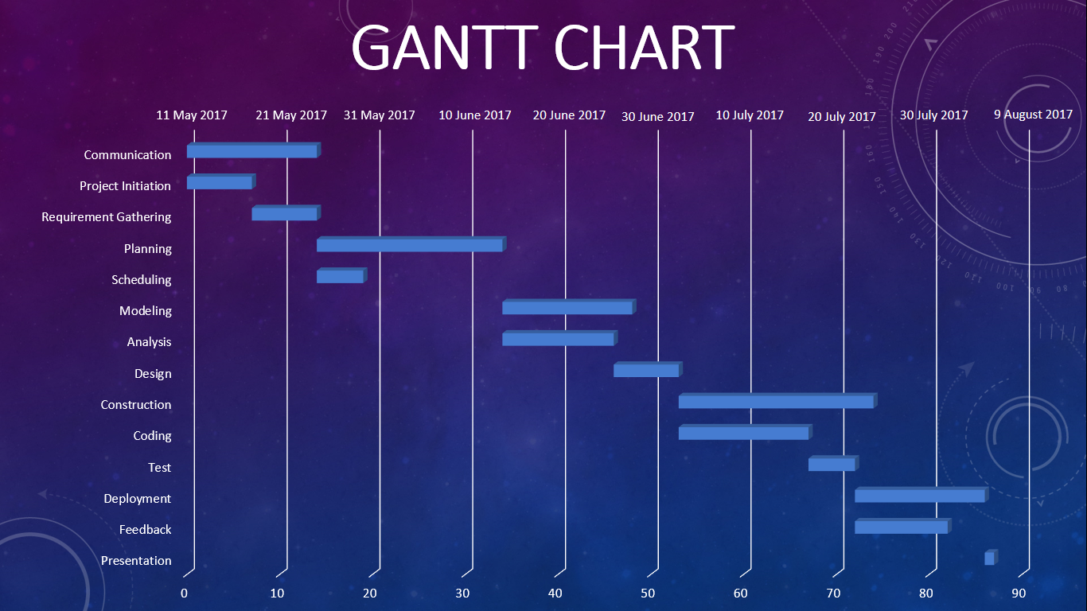

**Risk Analysis**

* Failure of completion the project by deadline.
* The client is not satisfied with the design and performance.
* Delaying of providing customer service.
* Undetected bugs and crashes appears.
* Any kind of storage failure that may result in wiping out the data.

**Conclusion**

This report included all the feasibility analysis, risk analysis, project scheduling and a rough sketch of the project. The project we proposed in is possible to complete within deadline and we hope it will be a success with the given resources we have.